MySQL Queries

1. List all order with username and total amount

SELECT o.id AS order_id, u.name AS customer_name, o.total_price, o.status

FROM orders o

JOIN users u ON o.user_id = u.id;

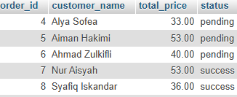

1. List order items with product name and quantity per order

SELECT o.id AS order_id, u.name AS customer_name, o.total_price, o.status

FROM orders o

JOIN users u ON o.user_id = u.id;

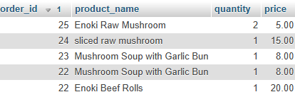

1. Get total number of orders per user

SELECT r.comment, u.name AS user_name, p.name AS product_name, r.created_at

FROM reviews r

JOIN users u ON r.user_id = u.id

JOIN products p ON r.product_id = p.id

ORDER BY r.created_at DESC;

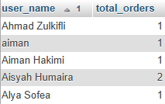

1. Get total sales amount for each product

SELECT p.name AS product_name, SUM(oi.quantity * oi.price) AS total_sales

FROM order_items oi

JOIN products p ON oi.product_id = p.id

GROUP BY p.id;

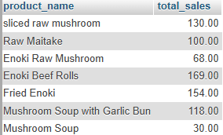

1. Get review comments with product and user

SELECT r.comment, u.name AS user_name, p.name AS product_name, r.created_at

FROM reviews r

JOIN users u ON r.user_id = u.id

JOIN products p ON r.product_id = p.id

ORDER BY r.created_at DESC;

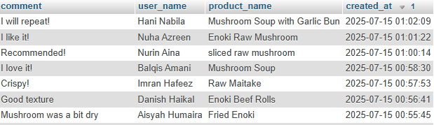

1. List all paid orders with payment amount and method

SELECT o.id AS order_id, u.name, p.amount, p.method, p.status

FROM payments p

JOIN orders o ON p.order_id = o.id

JOIN users u ON o.user_id = u.id

WHERE p.status = 'paid';

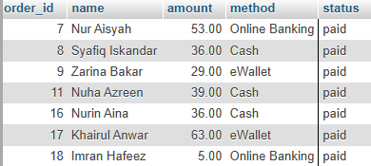

1. Find top 3 products with highest number of reviews

SELECT p.name AS product_name, COUNT(r.id) AS total_reviews

FROM reviews r

JOIN products p ON r.product_id = p.id

GROUP BY p.id

ORDER BY total_reviews DESC

LIMIT 3;

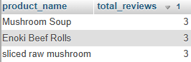

1. Count number of orders by status (e.g, pending/success)

SELECT status, COUNT(*) AS total

FROM orders

GROUP BY status;

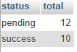

1. List users who have not made any orders

SELECT u.name

FROM users u

LEFT JOIN orders o ON u.id = o.user_id

WHERE o.id IS NULL AND u.role = 'user';

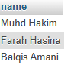

1. Display order history with product names and payment status

SELECT

u.name AS customer_name,

o.id AS order_id,

p.name AS product_name,

oi.quantity,

pay.status AS payment_status,

o.created_at AS order_date

FROM orders o

JOIN users u ON o.user_id = u.id

JOIN order_items oi ON o.id = oi.order_id

JOIN products p ON oi.product_id = p.id

LEFT JOIN payments pay ON o.id = pay.order_id

ORDER BY o.created_at DESC;

